

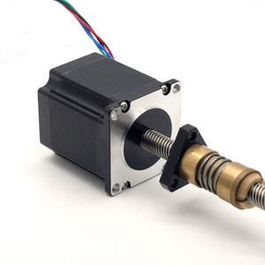57mm Linear Hybrid Stepper Series

**SPECIFICATIONS:**

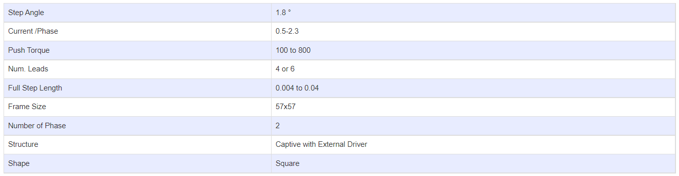

**Linear Stepper Motor Options:**

